Checkpoint #4

Last week we have determined what kind of data mining technique we used for analyzing the data and also gave a sample graph sheet of how the analyses looks.

This week we have entered all the player’s names and the number of goals secured.

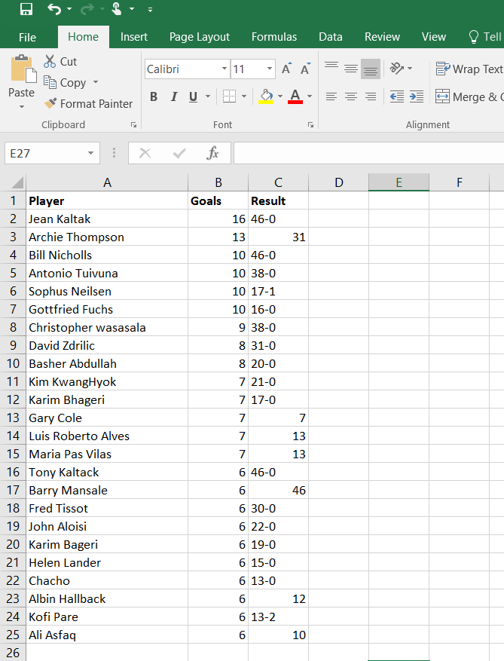

By using Text mining technique, we can extract the unstructured data for analyzing the information and identifying the relationship between the texts. It will structure the data inside the documents. It will help to visualize the data.

In the next week we will submit the outputs of the analyzed data showing the graphs and worksheets representing the number of goals achieved by the players.